Supplementary Materials for
Time Trends in United States Autism Prevalence with Co-Occurring Intellectual Disability: Is There a Signature of Thimerosal?

Cynthia Nevison

Contents
Supplementary Table S1: detailed sources of IQ data in each ADDM report
Supplementary Table S2: IQ data by gender and methodology
Section S2: Description of race/ethnicity bar graph formats
Supplementary Table S3, IQ data by race
Supplementary Figure S1, ID fraction trends in individual states
Supplementary Figure S2, ID fraction trends in consistent state groups

Supplementary Table S1. Detailed sources of intelligence quotient (IQ) data. Tables and
figures listed here refer to those in the ADDM reports.

Report Year | Birth Year | Overall | By sex | By race | By state | States included in IQ calculation
2000 | 1992 | Fig.4ª | Fig.4 ª | NA | Fig.4 ª | AZ,GA,SC
2002 | 1994 | Fig.4 ª | Fig.4 ^{a,b} | NA | Fig.4 ^{a,b} | AZ,AR,CO,GA,NC,SC,UT^{c}
2002 ^{d} | 1994 | 98 T5^{d,e} | NA | NA | 98 T5^{d,e} | AL,AZ,CO,GA,NC,SC^{c}
2006 | 1998 | Table 5e | Fig.3 ª | NA | Fig.3ª,T5e | AL,AZ,CO,GA,NC,SC
2008 | 2000 | p.9-10 ^{f} | Fig.2 ª | NA | Fig.2 ª | AZ,AR,GA,NJ,NC,SC,UT^{c}
2010 | 2002 | Abstract^{f} | Fig.2 ª | Fig. 4 ^{a,b} | Fig.2 ª | AZ,AR,GA,NJ,MD,NC,UT^{c}
2012 | 2004 | p.7^{f} | Fig.2 ª | Fig. 4 ^{a,b} | Fig.2 ª | AZ,AR,CO,GA,MD,NJ,NC,SC, UT
2014 | 2006 | Abstract^{f} | Fig.1 ^{a,b} | Fig. 2 ª | Fig.1 ^{a,b} | AZ,AR,CO,GA,MD,MN,NJ, NC,TN
2016 | 2008 | Table 3 | SI p.15 ^{g} | SI p.15 ^{g} | Table 3 | AZ,AR,CO,GA,MD,MN,NJ, NC,TN, WI
2018 | 2010 | Table 5 | Table 5 | Table 5 | Table 5 | AZ,AR,CA,GA,MD,MN,MO, NJ,TN,UT,WI
2020 | 2012 | Table 5 | Table 5 | Table 5 | Table 5 | AZ,AR,CA,GA,MD,MN,MO, NJ,TN,UT,WI
2022 | 2014 | Table 3 | Table 3 | Table 3 | Table 3 | AZ,AR,CA,GA,MD,MN,MO, NJ,PA,PR,TX,TN,UT,WI
ª IQ percentages read by state and sex from bar graphs using digitizing software, followed by weighting by state populations for nationwide estimate.
^{b} Only IQ <70 fraction available.
^{c} Bold font emphasizes change in participating states compared to adjacent row.
^{d} Retrospective tabular data in 1998 report that allowed estimation of all 3 IQ categories in 1994 report via Method 3, although with change in state composition.
^{e} IQ percentages calculated as ratios of absolute prevalences, tabulated in three IQ categories, to the sum across categories, followed by weighting by state populations for nationwide estimate.
^{f} Direct values given only in the text, i.e., not in a table.
^{g} IQ percentages read by race and sex from bar graphs for white, black, and Hispanic, using digitizing software, followed by weighting by overall racial composition of survey for nationwide estimate.

Supplementary Table S2. Nationwide IQ percentages, overall and for males and females

Method 1 (this study) weight state-level IQ percentages by total ASD count in the state.
Report Year | Birth Year | Overall IQ  % of total |  |  | Male IQ  % of total |  |  | Female IQ  % of total
 |  | < 70 | 71-85 | >85 | < 70 | 71-85 | > 85 | < 70 | 71-85 | >85
2000 | 1992 | 47.8 | 20.2 | 31.9 | 43.3 | 21.5 | 35.2 | 64.4 | 17.2 | 18.4
2002 | 1994 | 45.2 |  |  | 42.1 |  |  | 58.1
2006 | 1998 | 41.5 | 23.2 | 35.3 | 40.1 | 24.3 | 35.6 | 47.7 | 19.2 | 33.1
2008 | 2000 | 38.7 | 23.7 | 37.6 | 37.0 | 23.6 | 39.4 | 47.7 | 24.1 | 28.2
2010 | 2002 | 30.9 | 22.8 | 46.3 | 29.8 | 23 | 47.2 | 36.6 | 22.2 | 41.2
2012 | 2004 | 31.4 | 24.7 | 43.9 | 30.0 | 25.4 | 44.6 | 38.3 | 21.3 | 40.4
2014 | 2006 | 31 | 25 | 44 | 29.7 |  |  | 37.5
2016 | 2008 | 33.6 | 24.4 | 42 | 32.3 | 24.2 | 43.5 | 39 | 25 | 36
2018 | 2010 | 35.7 | 23.2 | 41.1
2020 | 2012 | 38.7 | 23.4 | 37.1
2022 | 2014 | 40.9
Method 2 (ADDM method) weight state-level IQ percentages only by ASD counts with IQ information.
Report Year | Birth Year | All Children IQ  % of total |  |  | Boys IQ  % of total |  |  | Girls IQ  % of total
 |  | <70 | 71-85 | >85 | <70 | 71-85 | >85 | <70 | 71-85 | >85
2008 | 2000 | 38 | 24 | 38
2010 | 2002 | 31 | 23 | 46
2012 | 2004 | 31.6 | 24.5 | 43.9
2014 | 2006 | 31 | 25 | 44
2016 | 2008 | 33.4 | 24.1 | 42.1* | 32 |  |  | 40
2018 | 2010 | 35.2 | 23.1 | 41.7 | 35.1 | 22.6 | 42.2 | 35.6 | 25.3 | 39.1
2020 | 2012 | 37.9 | 23.5 | 38.6 | 36.9 | 24.1 | 39 | 42.1 | 21.2 | 36.8
2022 | 2014 | 39.6 | 24.2 | 36.1 | 39.5 | 24.1 | 36.5 | 40.1 | 24.7 | 34.9
Method 3 – Calculate based on absolute prevalence of IQ percentages in Table 5 of 1998 report
Report Year | Birth Year | All Children IQ  % of total |  |  | Boys IQ  % of total |  |  | Girls IQ  % of total
 |  | <70 | 71-85 | >85 | <70 | 71-85 | >85 | <70 | 71-85 | >85
2002 | 1994 | 47.6 | 19.5 | 32.9
2006 | 1998 | 41.4 | 23.1 | 35.5
*Total adds up to only 99.6% across all IQ groups

Section S1. IQ by race/ethnicity: various bar graph formats 2002-2008
In 2002 and 2004, the race/ethnicity bar graphs were presented as overall nationwide absolute prevalences (in per 1,000) in stacked bars with IQ < 70, IQ > 70, and unknown IQ for Whites, Blacks, and Hispanics, combined across all states. For these years, the IQ percentages were read with digitizing software and the ID fraction for each available race/ethnicity (excluding API) was estimated as the ratio of the IQ < 70 prevalence divided by the sum of the IQ < 70 + IQ > 70 prevalences (ignoring the unknown IQ prevalence fraction).

In 2006 and 2008, the IQ percentages were presented in a bar graph combined over all states and broken out by race into Whites, Blacks, and Hispanics, with male and female bars for each race. The bars were read using digitizing software to estimate nationwide mean IQ percentages for males and females in each race/ethnicity group. The nationwide overall (male + female) IQ percentages for each race were estimated by weighting the male and female data based on the mean nationwide male:female ASD case ratio.

Uniquely in 2008, the race/ethnicity bar graph was used to estimate nationwide IQ percentages for all races, overall and for males and females, by weighting each race/ethnicity by its relative proportion in the nationwide survey (51.2% White, 21.2% Black, 21.4% Hispanic) (Table 3). For 2000-2006, this step was not necessary because those years also included state-specific IQ bar graphs combined for all races. The latter bar graphs were used preferentially in the application of Method 1 to derive mean nationwide IQ percentages for all race/ethnicities (Supplementary Table S1). However, in 2008, the race/ethnicity bar graph (which was presented only in that report’s Supplementary Information (SI)) was the only independent source of data for estimating the mean nationwide IQ percentages.

Note: in call cases, across 2000-2008, it was not clear from the text of the ADDM report how the nationwide race/ethnicity IQ bar graphs were computed from the state-level data, but presumably some form of Method 2 was used. The uncertainty in the race/ethnicity ID fractions from 2002-2008 was estimated as < ±1% (absolute) based on the good reproducibility of multiple recalibrations and readings of the bar graphs.

Supplementary Table S3. Nationwide overall IQ percentages by race/ethnicity

Birth Year | IQ group | 2002  % | 2004  % | 2006  % | 2008  % | 2010  % | 2012  % | 2014  %
White | IQ < 70 | 24.4 | 24.2 | 22 | 27.4 | 29.7 | 31.8 | 32.7
 | IQ 71-85 |  |  | 22 | 22.8 | 22.7 | 20.7 | 22.9
 | IQ > 85 |  |  | 56 | 49.6 | 47.6 | 47.5 | 44.4
Black | IQ < 70 | 48 | 49 | 44.7 | 47 | 49.8 | 50.8 | 52.8
 | IQ 71-85 |  |  | 28.5 | 26 | 21.9 | 25.1 | 26.1
 | IQ > 85 |  |  | 26.8 | 26.8 | 28.2 | 24.1 | 21.1
Hispanic | IQ < 70 | 38 | 36 | 35.5 | 36 | 33.1 | 34.9 | 38.8
 | IQ 71-85 |  |  | 28.5 | 28 | 25.7 | 27.5 | 25.1
 | IQ > 85 |  |  | 36 | 36 | 41.2 | 37.6 | 36.1
Asian | IQ < 70 |  |  | 40.2 |  |  | 41.3 | 43.9
 | IQ 71-85 |  |  | 28.1 |  |  | 21.8 | 22.6
 | IQ > 85 |  |  | 31.9 |  |  | 36.9 | 33.5

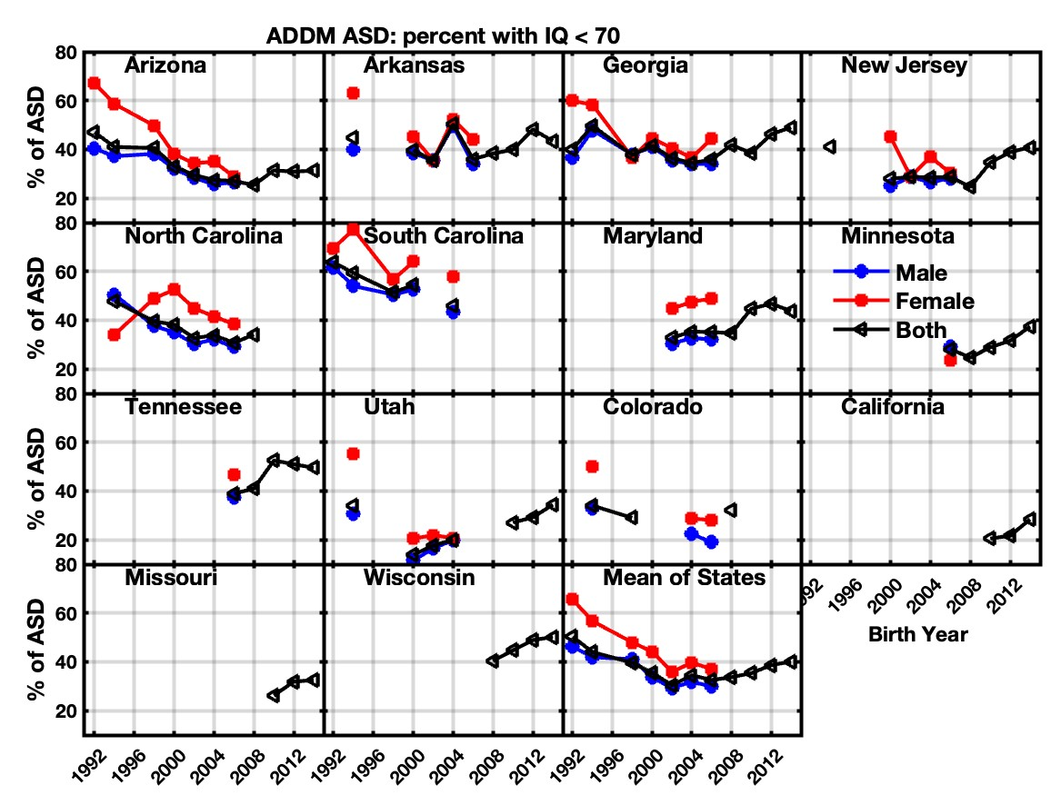
Figure S1. ID fraction (i.e., percentage of ASD cases with IQ < 70) in individual states: overall (black), boys (blue); girls (red) computed using Method 1. Final panel shows the mean of the other 14 panels, including all non-blank values for any given birth year.

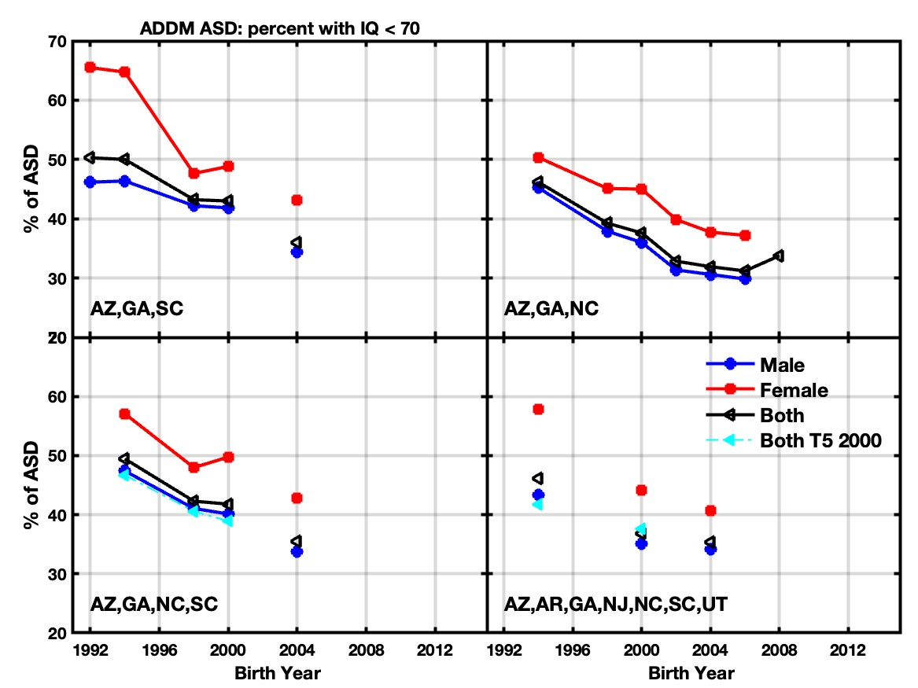
Figure S2. Same as Figure S1 but for consistent groups of states that span the 1992-2004 birth year period for which large drops in ID fraction were observed. Filled cyan triangles show the overall ID fraction estimated by applying Method 3 to the comparative data presented in Table 5 of the birth year 2000 ADDM report*

* The 2000 ADDM report included a comparative table, similar to the one in the 1998 ADDM report, which presented absolute ASD prevalences in 3 IQ groups for 2000 and compared them retrospectively to both 1994 and 1998. Method 3 was applied to these data to estimate the change in ID fraction for a consistent 4-state group (AZ, GA, NC, SC) across the three report years from 1994-2000 as well as a 7-state group in 1994 and 2000 (AZ, AR, GA, NJ, NC, SC, UT). These estimates are compared to Method 1 results in Supplementary Figure S2 but otherwise are not emphasized here due to numerous inconsistencies both within the 2000 Table 5 itself and compared to 1998 Table 5. The 2000 Table 5, however, was the sole source of information across all the ADDM reports about prevalence by race/ethnicity in 1994 and 1998 as well as IQ in NJ in 1994.

